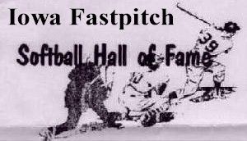
Iowa Men’s Fastpitch HOF’er
June 15, 2026
2026 Softball Induction Sunday the 25th
Our event is only Sunday but we’re hopeful groups will plan their own overnight stays in relatively close hotels/motels so additional celebrations can occur.
Plans are for 2026 Hall of Fame new members’ induction on Sunday the 25th. This will be an informal gathering for those involved in fast pitch softball and is open to all participants plus families as well as fans of the game. Be encouraged to spread the word.
HOF Induction
Sunday, October 25, 2026 from 11:00am to 4:00pm
Estimate HOF Inductions Start: 1:30pm
Tara Hills Country Club
1846 70th St, Van Horne, IA 52346

The ceremony will include a luncheon with a three meat, buffet, potato, salads, rolls, water, lemonade and coffee. As of this message, the cost of the meal ticket to attend will be $25/person.
The doors will open at 11:00am with the meal to take place at noon and the induction will proceed after the meal is completed.
Be on the alert for future updates as the event gets closer.
Thank-you
Leroy Wegmann
319-560-5254
leroyweg@outlook.com

